Analysis of Seattle PD

# Officer quit analysis

Based on the assumption that officer's last date in the CAD data is their quit date, (1) I did a day-level aggregate of the quit date per officer count. (2) I did a month-level aggregate of the quit date per officer count which I sent to you earlier. (3) I then investigated if we had more quits per day and more quit days per week in each year.

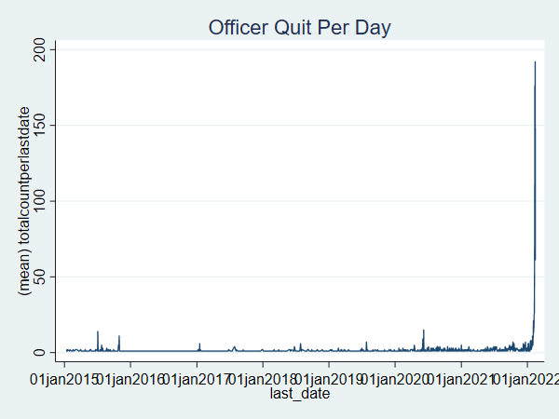

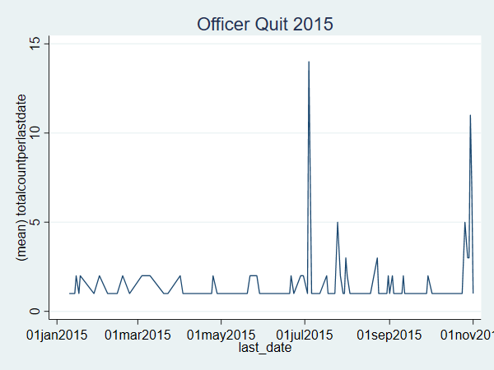

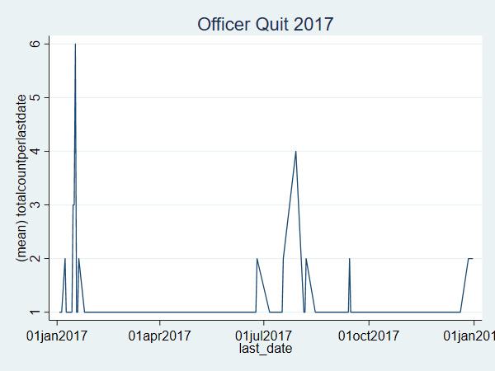

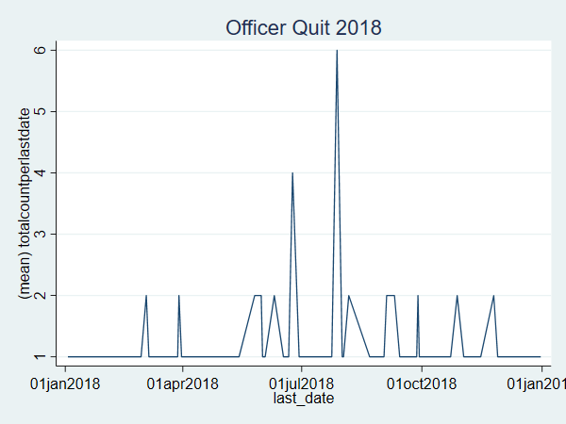

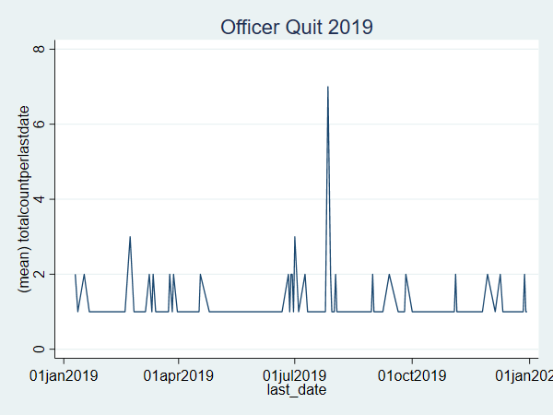

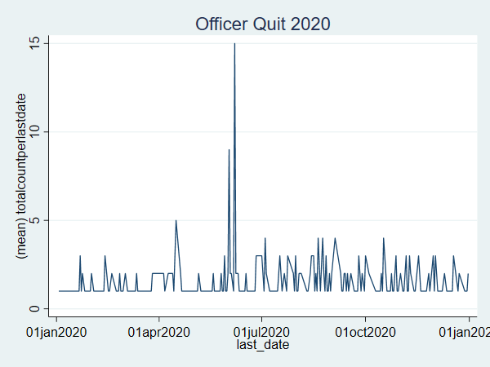

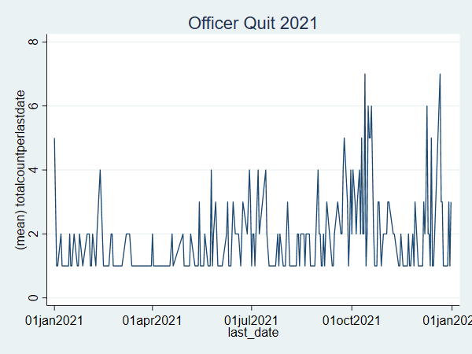

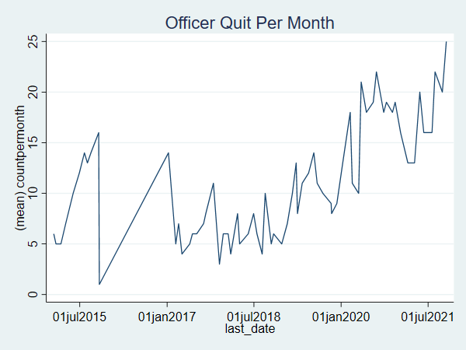

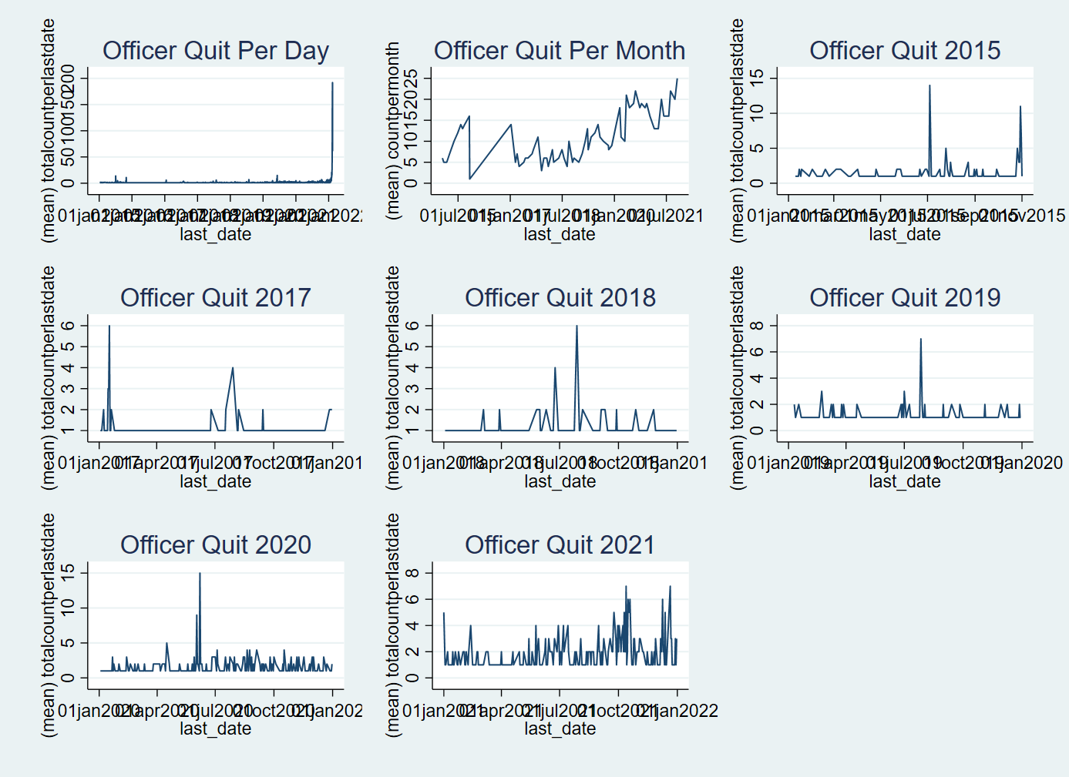

# Arrest data analysis

Now, I will be looking at the arrest data to investigate arrest rate per day, per month, and in 2021 precisely. The question is did the high quit rate in 2021 affect arrest rate and what has been the historical arrest rate?

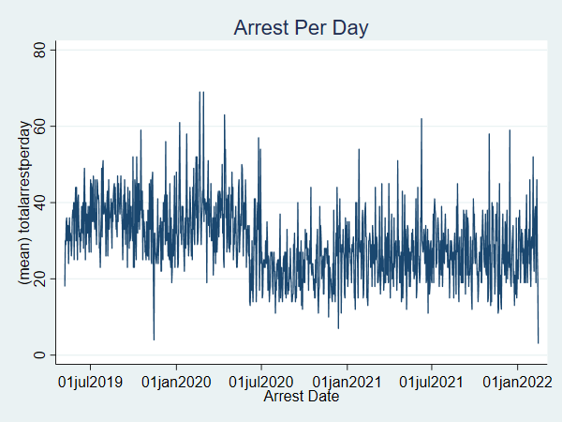

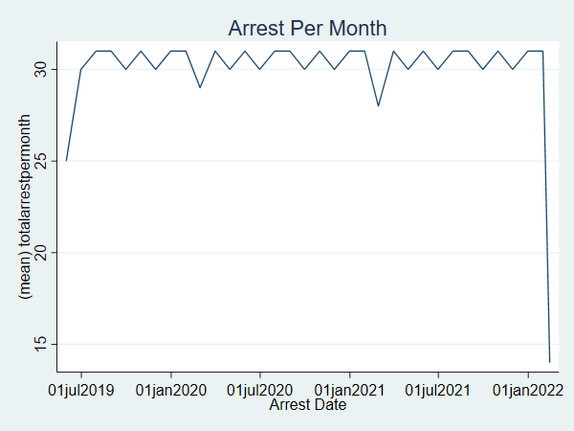

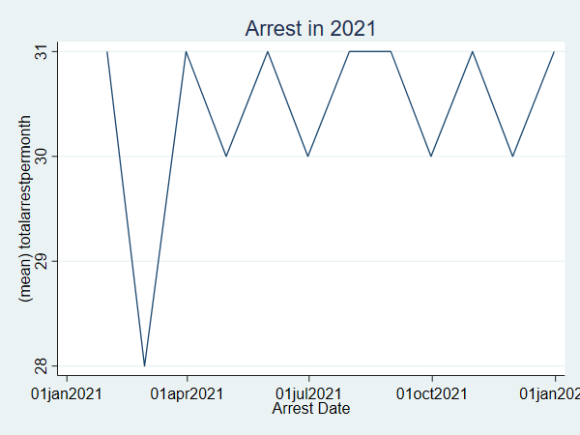

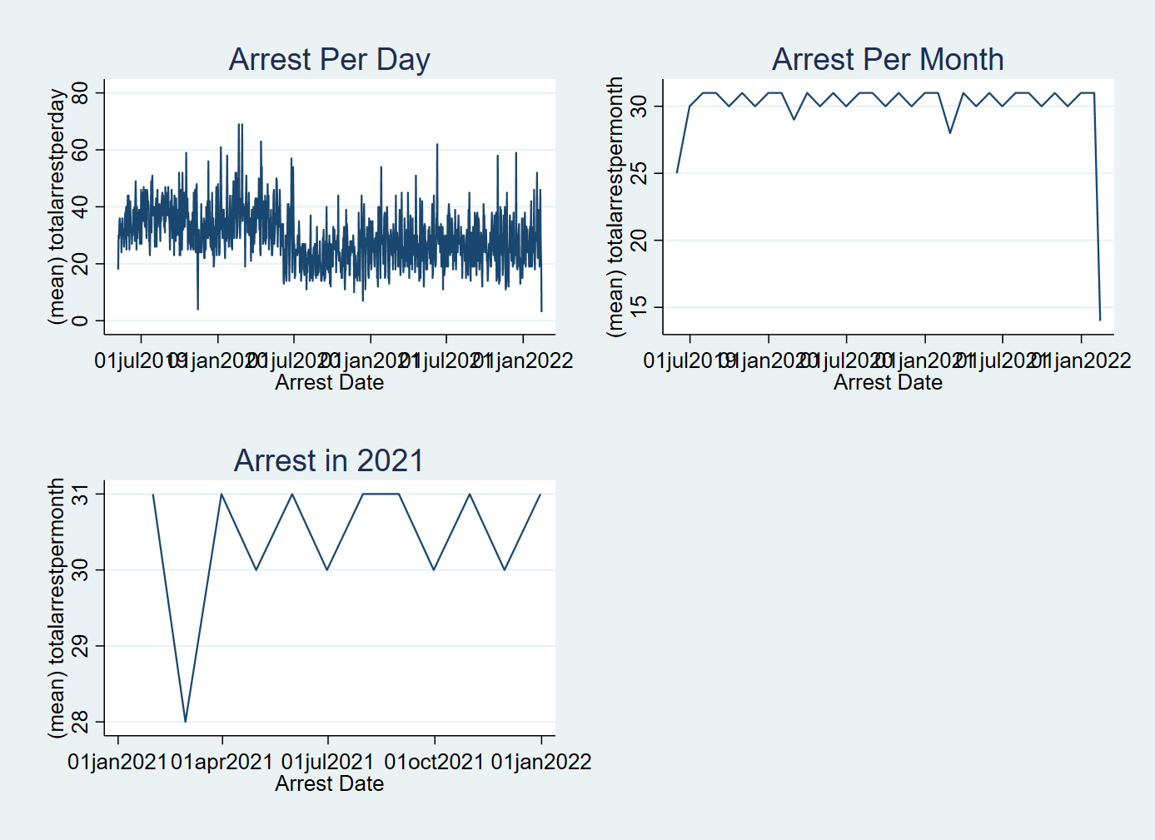

# Stop data analysis

Now, I will be looking at the stop data to investigate stop rate per day, per month, and in 2021 precisely. The question is if the arrest rate is affected or not, is the stop rate affected and what has been the historical stop rate? Here, I assumed that the fieldcontactid variable represents each stop made by officers.

